TOWES – Test of Workplace Essential Skills

Goal Planning Essentials

Workbook
Unit 3: Creating a Work Plan

TOWES Goal Planning Essentials
Care has been taken to obtain copyright permission to reproduce this material. Any information that will enable Bow Valley College to obtain copyright clearance for any material not acknowledged would gladly be received by:
Bow Valley College
345 6th Avenue SE
Calgary AB T2G 4V1
Attn: Copyright Office
email: copyright@bowvalleycollege.ca
© 2015 Bow Valley College

This work is licensed under a Creative Commons Attribution-ShareAlike 4.0 International License.

These resources may be reprinted without additional copyright permission. Full attribution to Bow Valley College must be given.

This project/resource was funded by the Alberta Open Educational Resource (ABOER) Initiative, which is made possible through an investment from the Alberta government.

How to use this eWorkbook:
This workbook is meant to guide learners in a step by step method to attaining the stated learning outcome listed on the first page. Print this workbook out and write notes in the margins. Fill in the learning activities using a pencil to allow for mistakes and brainstorming during your learning process.

You may choose to complete this workbook on your own, but it may be helpful to locate a mentor or trusted friend or advisor to give you feedback on your completed learning activities.

Make sure to explain or summarize the main concept of the unit and the purpose of each learning activity to your mentor before you ask for feedback. The purpose of this collaboration is NOT for your mentor to tell you that something is right or wrong, but rather just to give you some constructive and objective feedback that may allow you to look at things in a new way or from a different perspective. Chances are that if you can clearly explain the concepts of the unit and your mentor understands what you have completed in your learning activities - you are on the right track.

Essentially, you have the final say on how you complete your learning activities, and how you use the templates provided in this course, but generally a good rule of thumb is that two heads are always better than one! If you are having difficulties working on your own, ask someone for help or feedback.

Step 1: Read the entire workbook.
Step 2: Complete the learning activities.

Step 3: Ask for feedback on learning activities from a mentor or trusted advisor.

Step 4: Use the templates for school, home, or work situations.

The Story:
Wilson’s Furniture

Welcome to Unit 3 of the Goal Planning Essentials Learning Series. This unit is about creating Work Plans that can help you to visualize the step-by-step tasks or processes involved in reaching your goals big or small.

Meet Wilson. This is his story and how he uses simple project management approaches, strategies and tools that help him to make plans and outline the steps that he needs to follow in order to get things done. Wilson is a talented carpenter and owns his own wood furniture business. He has a small workshop and storefront connected to his house. Customers come by the workshop to purchase the beautiful furniture that he makes and sometimes he is required to consult with his clients on special orders for custom made furniture.

Wilson often works on many projects at once and needs to set large and small goals on a regular basis to keep his business running smoothly. Obviously, he has a lot going on so Wilson must be efficient and organized with what he focuses on first and how he prioritizes his time. Sometimes things can get overwhelming. He had the opportunity to take a course on setting and managing goals a few years ago at a local community college and learned a few key strategies that have helped him to become more efficient and better at thinking about and planning what he needs to do and when. He is in the process of hiring a new apprentice to help him with some of this projects and to help run the shop, so being clear and defining his project goals properly is essential.

Throughout this unit you will be shown some basic examples of approaches and strategies that Wilson uses to help keep him focused and organized.

Unit 3: Creating a Work Plan
Q: Why is it important for me to sharpen my goals?
Creating a work plan is a little bit like mapping out the direction and the clearly defined steps that you will need to take in order to get to a final destination. Without a work plan you would not know which steps are important to do first. You would not know how long it might take reach your goal. Without a work plan, you may not end up where you want or hoped to be.
Q: How long will it take me to complete this workbook?
It should take learners about 2 to 2.5 hours to complete this unit.

Learning Outcome
When you complete this unit you will be able to...
Utilize various project management planning approaches and strategies to help create a step-by-step work plan.

Learning Objectives
Unit 3 focuses on the following Objectives:
- Outline the basic phases of managing a project big or small.
- Explain how ‘To-do Lists’ can be used for goal completion
- Explain how ‘Flow Charts’ and ‘Work Break Down Structures’ can be useful tools in helping to complete a goal big or small.
- Create a basic ‘Work Plan’ to aide with the completion of a SMART Goal

Learning Activities
Please complete the following learning activities:
- Learning Activity 1: Create a To-do List & Task Sheet
- Learning Activity 2: Create a Flow Chart
- Learning Activity 3: Create a Work Breakdown Structure
- Learning Activity 4: Create a Basic Work Plan
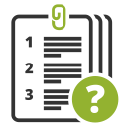

OBJECTIVE ONE
When you complete this objective you will be able to…
Outline the basic Phases of Managing a Project Big or Small.

Learning Material

Tasks vs. Projects
“Projects” range from very simple to very complex, but one thing they all have in common is that they all have an end goal in mind. Hopefully, it is a SMART goal! Let’s take a minute to think about the word “project” and what it means. A project can be defined as an individual or group endeavour that is carefully planned with a step-by-step approach and is designed to achieve a particular aim.
Typically, most projects comprise of a series of activities that needed to be completed by a specific date and within a specific budget. Projects also have numerous tasks or steps involved that need to be coordinated or planned. It is important to note that a single task is not usually considered a project. So, depending on the size of your SMART goal you might not require that it be planned as a project.
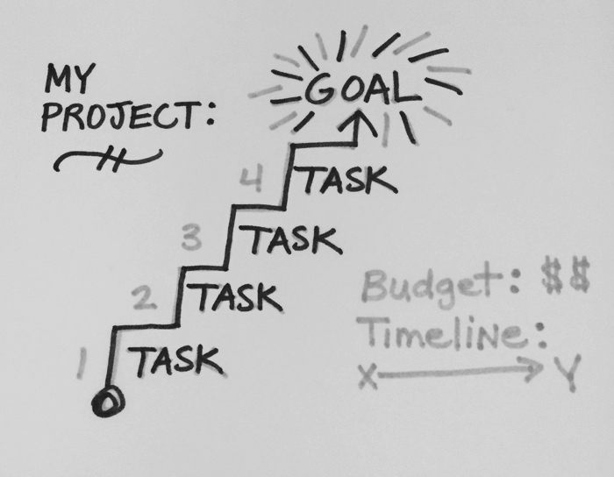
If your smart goal is closer in scale to a single task, maybe a simple to-do list or task ticket will work just fine. If your project is a little bigger in size, and complexity and has multiple tasks then maybe treating it more like a “project” with a Flowchart, Work Break Down Structure or Work Plan may be useful.
We will get into more detail on how to use these planning strategies. The approaches may be unfamiliar right now but by the end of the unit you should have a clear idea on how to use the following items to help you plan and achieve your SMART goal (big or small)…
- To-do list: Short lists with 3-5 ‘quality’ tasks (daily or weekly)
- Task Ticket: More detailed or complicated tasks listing each step
- Flow Chart: A visual chart that shows a directional flow or process of an activity or task
- Work Break Down Structure: A visual snapshot of the entire project that is broken down into key activities and show the specific sequence or order that each task needs to be completed in.
- Work Plan: A table or excel spreadsheet that lists a detailed account of each task in the project and documents what tasks or activities are completed and what ones are not.
Remember, that these are just tools that can be used to help you plan. It is up to you on how you choose to customize or adapt the tools to work best for you and your specific goal or project. For any SMART goals that are a little more complex and require the coordination of numerous tasks, it may be useful to treat them like a project and utilize some very basic Project Management principles.
According the Project Management Institute, Inc. (PMI) most projects when divided up into key activities have the following phases:

Initiate

Plan

Build / Execute

Close / Complete

Here is a detailed description of what activities go on in each phase:
1. Initiate the Project | Come up with the idea or the SMART Goal and define the purpose, objectives, and deliverables of the project.  - Write your SMART goal  - Conduct a SWOT analysis
2. Planning the Project | Outline the work that needs to be done in order to meet the project goal. Prioritize each of the project activities or tasks, calculate a budget and time schedule, and determine what types of resources are needed.  - Create a Flow Chart, Work Break Down Structure, AND/OR a Work Plan
3. Building the Project | This is the phase where you actually complete all the work and project tasks and activities listed in the Work Break Down Structure, or Work Plan documents.  - Monitor the Work Plan here to make sure the project is on time and budget
4. Closing the Project | After the project is done is it helpful to reflect on what was done well and what could be improved upon next time or lessons learned.  - Think about or list lessons learned

OBJECTIVE TWO
When you complete this objective you will be able to…
Explain how ‘To-do Lists’ can be used for goal completion

Learning Material

Do you ever feel overwhelmed with all the things you need to get done or accomplish? Perhaps you need to meet a certain goal, or maybe you just need a good way to manage your day? To-do lists are a simple approach in helping you to prioritize what you need to get done and can increase your ability to be efficient, focus on the right things to be productive and efficient with your time.
Let’s take a look at our friend Wilson as mentioned in the case study on page two of this workbook. Wilson owns a wood furniture store. He builds the furniture and sells his work out of a small shop connected to his house. He has many things to get done in a day, week or month and he has to prioritize them. He often uses to-do lists to help him stay organized and focus on the right tasks at the right time. The things that Wilson needs to get done are smaller in scale, and are not complex enough to be considers a project.

Before we get started on Wilson’s to-do list, here are some basic guidelines for writing to-do lists:

Step 1 | Write down all the things you need to get done on a large piece of paper. Your ‘Task List’ might include items that need to get done today, this week or this month.
Step 2 | Looking at your task list from step 1, if you have many items on your list… think about creating more than one  To-do list that is grouped into work, home, and school categories. Only make as many lists that make sense to you and your to-do items.  Note: Ideally it is important to keep your to-do lists simple, with not more than 3 to 5 items for each list.
Step 3 | Looking at your task list again. Rate each task with either an A, B, C or D:  - A = Urgent! Complete task now!  - B = Very Important – do as soon as possible  - C = Important but can wait  - D = Would be nice to complete at some point
Step 4 | Get out 1 piece of paper for each to-do list that you are making: (Example: Home, School and or Work)
Step 5 | Referring to your task list, write down each task on the appropriate to-do list (home, school, work) grouping all the “A” items together, the “B” items together, the “C” items together, and the “D” items together.
Step 6 | Assign an estimated time or date of completion to each of your tasks.
Step 7 | Cross each item off your to-do list as you get them done! It’s important to see that you are making progress…  Reward yourself once each to-do list has all the items crossed off the list. (Maybe your favourite TV show or specially prepared beverage!)

Here is an example of how Wilson created a to-do list for the things that he needed to get done around home and at his workshop. He assigned a priority letter A, B, C, & D to each of the items:

Wilson’s Sample Task List

My Task List:
- Gas up the car (B)
- Pay Business taxes (B)
- Sweep out the shop (C)
- Pick up cat food (C)
- Deposit store sales to bank (A)
- Go to gym (B)
- Stop by health food store (D)
- Get quote completed for the table and chairs set for Fred Johnson (A)
- Complete employees schedules for next month (C)

After Wilson completed his task list above he realized that he needed to make two To-do lists… one for Work and one for Home stuff that he could get done on his next day off of work. He decided to use the big sticky notes because there weren’t that many items on each list, and he could easily post them up on the fridge or on his computer at work.
Work:  - Pay Business taxes (B)  - Sweep out the shop (C)  - Deposit store sales to bank (A)  - Get quote completed for the table and chairs set for Fred Johnson (A)  - Complete employees schedules for next month (C) | Home:  - Gas up the car (B)  - Pick up cat food (C)  - Go to gym (B)  - Stop by health food store (D)

Wilson then decided that it was worth rearranging the items into order of priority from urgent to least urgent items and noted completion times and days to help him stay organized. Notice how the A’s are listed first, then the B’s, C’s and D’s? He also wrote the due dates / times in a different color.

Work:  - Deposit store sales to bank (A) Today 10:00 am  - Get quote completed for the table and chairs set for Fred Johnson (A) Today by 3:00pm  - Pay Business taxes (B)  Be at bank by 3:30pm  - Sweep out the shop (C)  Today at 5:00pm  - Complete employees schedules for next month (C)  By the end of next week | Home:  - Gas up the car (B)  Saturday 10:00 am  - Pick up cat food (C)  Saturday 10:30 am  - Go to gym (B)  Saturday 11:00am  - Stop by health food store (D)  on way home from gym!

Professor E says… No more than 3-5 items on your To-do List! It should not be an exhaustive list. It’s better to focus on 3 to 5 achievable items and get the tasks done and feel good about it, rather than 20 items that will overwhelm you.

Tips for writing To-Do lists:

- Try to keep your to-do list simple no more than 3 to 5 items

- Make sure that your items are important enough to warrant being on the list at all. (Example: brushing your teeth or getting dressed in the morning doesn’t need to be on your to-do list!)

- Complete your to-do list the night before. Your to-do list should be ready to go when you start your day… allowing you to tackle it early in the day!

Learning Activity 2: Create a
To-Do List & Task Sheet
Complete the Learning Activity listed below…
Spend 5-10 minutes creating a list of all the tasks that you need to complete for home, work and school over the next few weeks:

My Task List:
list items here…

Looking at the task list above create two different To-do lists that have no more than 3 to 5 items on each list.
Work: | Home OR School:

OBJECTIVE THREE
When you complete this objective you will be able to…
Explain how ‘Flow Charts’ and ‘Work Break Down Structures’ can be useful tools in helping to complete a goal big or small.

Flow Charts

When a person needs to follow a step-by-step process to reach an end goal, it can be helpful to visually ‘map’ out the entire process from start to finish. These maps are referred to as ‘Flow Charts’. A flow chart is almost like a treasure map that uses various shapes to indicate where you need to start and what steps you need to follow to reach the end goal. This includes the start of the process, arrows to show the direction or flow of the process, steps that happen throughout the process, the decisions that need to be made, documents that might be used, and finally the end of the process.

Here are the basic shapes that are used within a flow chart and what they mean:
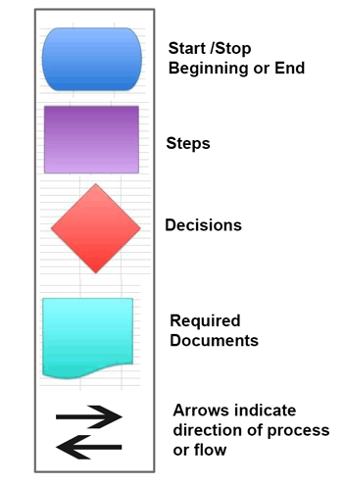
Flow charts are useful when you need to communicate or plan out what steps need to happen and when in order to reach a certain outcome or goal. Wilson is currently hiring an apprentice to help him with his business and he wants to clearly communicate what happens when he has to consult with a customer that is requesting a special order. Here is an example of a process that Wilson uses when he gets a request from a customer to build a custom piece of furniture for them.
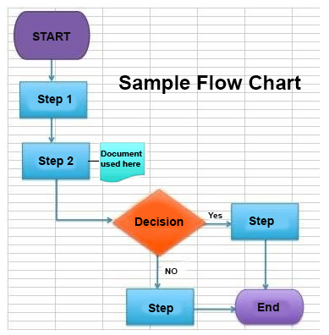

Step 1: | Meet with the customer to determine what they want
Step 2: | Come up with a furniture design & quote  (‘Furniture Design Document’ used here)
Decision: | Does the customer want to proceed with the design & quote?
Yes: | Build the furniture that is specified in the design for the agreed upon price
No: | Back to Step 1

Notice how Wilson can quickly and easily communicate or visualize the process by using a Flow Chart? It also encourages Wilson to look at what steps he is doing and when and whether or not he may need to modify things to be more effective or efficient at reaching the final outcome. Flow charts help give us a bird’s eye view and can be a good strategizing and communication tool for ensuring a process is efficient and is focused towards a specific goal or outcome.

Only use them when it makes sense. It’s not a requirement that every single goal has a flow chart attached to it, but they can be helpful in certain instances when you are trying to strategize, plan or communicate your goals or ideas that involve some sort of process.

Work Break Down Structures

When defining specific complex tasks, it is important to think about the various “sub-tasks” involved in the work you need to do. A useful tool to use that can help you to think about subtasks is called a Work Breakdown Structure (WBS). Unlike the Flow Chart, WBS does not capture any yes or no decisions. They are simply used to define the steps and sub steps that need to happen in order to accomplish, achieve or produce a specific tangible result.

A Work Break Down Structure is a type of chart that can clearly define a series of complex steps that need to happen in a specific order. Wilson wanted to depict the process of building a table to his new apprentice. The chart needed to have enough detail that the apprentice would have a clear understanding of the 5 main steps involved in the current project that Wilson was about to start for a client. He not only wants to communicate the 5 main steps involved, but also the sub-steps involved for each step.
Figure 1: Example of a Work Break Down Structure for building a wooden table.
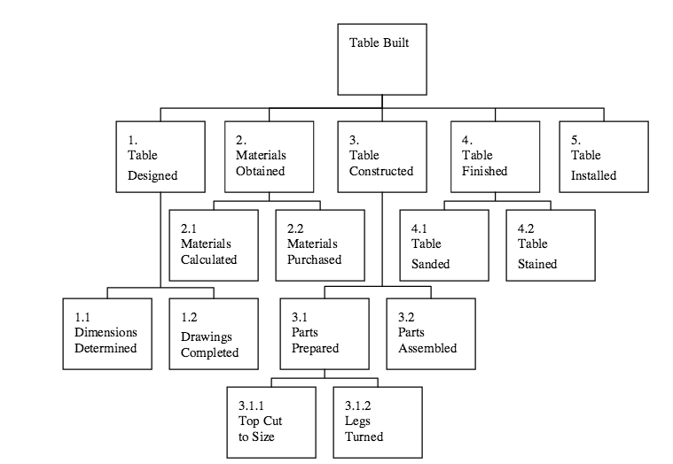

Before Wilson drew his WBS chart he created a “written schedule” that depicts the key steps and the sub-steps involved in the project.

First Wilson determined the key steps:

- Table Designed
- Materials to build table purchased
- Table is constructed
- Table is stained and finished with a high-gloss lacquer
- Table installed at clients house

Next, Wilson thought about the sub-steps required for each of the 5 steps:

- Table Designed
  - Dimensions Determined
  - Drawings Completed

- Materials to build table purchased
  - Materials Calculated
  - Materials Purchased

- Table is constructed
  - Parts Prepared
    - Top cut to size
    - Legs turned
  - Parts Assembled

- Table is stained and finished with a high-gloss lacquer
  - Table Sanded
  - Table Stained

- Table installed at clients house

The schedule is then put into a simple visual format called a work breakdown structure (WBS):

Professor E says… Keep it simple.
To help with your planning use sticky notes. Move the sticky notes around as needed until your process is satisfactory. Once you have the flow and steps determined just use plain paper and a pencil to draw your flow chart or Work Breakdown Structure.
Although you have the option to use some of the fancy and high tech flow-charting computer software out there, it is not necessary!

Learning Activity 3: Create a
Flow Chart & WBS
Complete the Learning Activity listed below…
1. Using the example in the reading, draw a simple Flow Chart outlining all the steps and decisions that you need to make in order to make ONE of your SMART goals a reality. It must fit on one single page, be simple enough to get a birds eye view of the process, but complex enough to clearly define the process.

2. Create a simple Work Break Down Structure that shows a small project or task that consists of 5 main steps or less. You must indicate at least 1-2 sub steps for each main step. Include both the “written schedule” as seen on page 15 and the WBS chart. Use more than one page if required.

1. Draw FLOW CHART here:

Ask your mentor for feedback on this activity once you are done!
2. Create WBS schedule and chart here:

Ask your mentor for feedback on this activity once you are done!

OBJECTIVE FOUR
When you complete this objective you will be able to…
Create a basic ‘Work Plan’ to aide with the completion of a SMART Goal

Learning Material

Work plans are simple charts that summarize the tasks that need to get done for a specific project or goal in order of priority. It may include various types of resources (technical, people, tools, information or supplies) that may be required, along with the due date and what state of completion the task is at.

Work Plan Template A: Simple Work Plan

State Project or Goal Here:

Rank  # | Task | Resources  Needed? | Date Due | Completed?
You can make your work plans as simple or as complex as you need them to be depending on the complexity of the project goals and needs. See an example below of a more complex work plan:

WORK PLAN TEMPLATE B: Detailed Work Plan
Project or Goal:

Rank  # | Goal & Sub Tasks | Collaboration  Required? | Resource Needs? | Date Due | Any Anticipated Obstacles? | Possible Solutions? | Progress Made or % of completion

Keep in mind: The purpose of the Work Plan Template is to break down the project into small actionable tasks or steps.

Another type of work plan that you might hear about frequently is called a Gantt Chart. Typically, project managers schedule the various tasks that need to be done to complete large complex projects using Gantt charts. It shows a schedule of all the various tasks and their start and finish dates. So the viewer gets a visual sense of the complexity of the project and how close the project is to completion.

In this unit of learning we will not be covering Gantt charts in detail but wanted to mention them here in passing because they are similar to work plans and you may come across them in other projects at work or school.
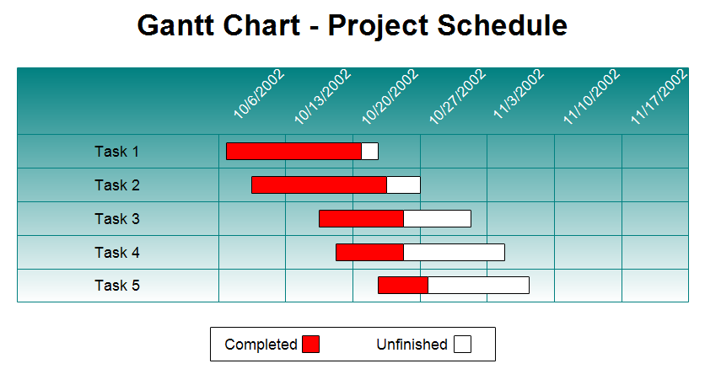
Reference: http://www.rff.com/ganttcharts.htm

Learning Activity 4: Create a
Work Plan
Complete the Learning Activity listed below…
Use a SMART goal or a basic project to create a simple Work Plan.

Work Plan Template A: Simple Work Plan

State Project or Goal Here:

Rank  # | Task | Resources  Needed? | Date Due | Completed?

Please Note:
You can make your work plan as simple or as complex as you need for the project or goal.
Ask your mentor for feedback on this activity once you are done!

Unit 3: Building Vocabulary
Directions:
- Read the list of the 25 terms below
- Use either Google, or an online dictionary, to define each word.
- On a piece of paper, write down the meaning of the word in English
- If English is NOT your first language translate it into your native language using an online translator tool such as https://www.babelfish.com/
- Do this for each word listed below

  - Mapping
  - Approach
  - Project
  - Task
  - Budget
  - Coordination
  - Initiate
  - Execute
  - Monitor
  - Prioritize
  - Guideline
  - Scope
  - Scale
  - Priority
  - Process
  - Requirement
  - Instance
  - Structure
  - Complex
  - Apprentice
  - Schedule
  - Summarize
  - Requirement
  - Completion
  - Frequently

References

TO-DO lists – The Key to Efficiency
https://www.mindtools.com/pages/article/newHTE_05.htm

Five Best To-List Tips:
http://www.forbes.com/sites/vanessaloder/2014/06/02/five-best-to-do-list-tips/

Task Sheets
http://davidseah.com/node/the-task-order-up/

Flow charts:
http://www.ehow.com/about_5081911_symbols-used-flowchart.html

http://www.riversideca.gov/audit/pdf/process%20mapping%20guidelines.pdf

Work Breakdown Structures and Scheduling http://people.ucalgary.ca/~design/engg251/First%20Year%20Files/wbss.pdf

Open Educational Resource | TOWES – The Test of Workplace Essential Skills is Canada’s premier literacy and essential skills assessment. Over 120,000 people have used TOWES on their pathways to success in education, employment and life.  