TOWES – Test of Workplace Essential Skills

Research Essentials

Workbook
Unit 4: Presenting
Information

Copyright
This document contains material reproduced with permission from the following sources. Resale or further copying of these materials is strictly prohibited.
Images
Unit 4 – Page 7 Cartoon Shaun McCallig ID smgn64

TOWES Research Essentials
Care has been taken to obtain copyright permission to reproduce this material. Any information that will enable Bow Valley College to obtain copyright clearance for any material not acknowledged would gladly be received by:
Bow Valley College
345 6th Avenue SE
Calgary AB T2G 4V1
Attn: Copyright Office
email: copyright@bowvalleycollege.ca
© 2015 Bow Valley College

This work is licensed under a Creative Commons Attribution-ShareAlike 4.0 International License.

These resources may be reprinted without additional copyright permission. Full attribution to Bow Valley College must be given.

This project/resource was funded by the Alberta Open Educational Resources (ABOER) Initiative, which is made possible through ab investment from the Alberta government.
.

How to use this eWorkbook:
This workbook is meant to guide learners in a step by step method to attaining the stated learning outcome listed on the first page. Print this workbook out and write notes in the margins. Fill in the learning activities using a pencil to allow for mistakes and brainstorming during your learning process.

You may choose to complete this workbook on your own, but it may be helpful to locate a mentor or trusted friend or advisor to give you feedback on your completed learning activities.

Make sure to explain or summarize the main concept of the unit and the purpose of each learning activity to your mentor before you ask for feedback. The purpose of this collaboration is NOT for your mentor to tell you that something is right or wrong, but rather just to give you some constructive and objective feedback that may allow you to look at things in a new way or from a different perspective. Chances are that if you can clearly explain the concepts of the unit and your mentor understands what you have completed in your learning activities - you are on the right track.

Essentially, you have the final say on how you complete your learning activities, and how you use the templates provided in this course, but generally a good rule of thumb is that two heads are always better than one! If you are having difficulties working on your own, ask someone for help or feedback.

Step 1: Read the entire workbook.
Step 2: Complete the learning activities.

Step 3: Ask for feedback on learning activities from a mentor or trusted advisor.

Step 4: Use the templates for school, home, or work situations.

The Story:
David’s Pasta Presentation

Welcome to Unit 4 of the Research Essentials Learning Series. Meet David. This is his continued story about how he conducted research on various types and cooking methods of the best Gluten-Free Pasta. As previously mentioned, David is a chef at a small café that specializes in gluten free menu options. He wants to offer his customers the best tasting pasta available and hopes that they would not be able to taste the difference between the regular pasta dishes and the gluten free options.

Over a period of 3 days, David conducted a test kitchen at his restaurant where he was serving free bowls of various types of Gluten-Free Pastas. Customers were asked to fill out a simple 5-question survey and David also conducted informal interviews focusing on questions about flavor, texture, and consistency. His results included approximately 150 written surveys, and 20 informal interviews.

David was asked to present his findings in person to the writing team at a local food magazine called Foodie Goody. After the presentation is completed he will work to create a written article with the writing team for publication in the Spring Edition of the magazine. David knows this will not only be positive exposure for his restaurant but will also spread awareness about Celiac Disease and gluten-free cooking options for celiac sufferers.

Unit 4: Presenting Information
Q: Why is it important for me to learn this material?
Presenting your research findings may be as important as the research you do. Communicating your results helps others to clearly understand what your research was about and the importance of your topic and final conclusion.
Q: How long will it take me to complete this workbook?
It should take learners about 1.5 hours to complete this unit.

Learning Outcome
When you complete this unit you will be able to...
Describe various presentation preparation strategies, rules of thumb for communicating key concepts and ways to create and deliver clear and effective presentations.

Learning Objectives
Unit 4 focuses on the following Objectives:
- Describe how to plan and storyboard a presentation
- Describe interesting and memorable ways to start a presentation
- Outline visual design best practices when creating a presentation
- Outline important non-verbal elements to be aware of during face-to-face communications with others.

Learning Activities
Please complete the following learning activities:
- Learning Activity 1: Notes & Storyboards
- Learning Activity 2: An Interesting Start
- Learning Activity 3: Create a Presentation
- Learning Activity 4: 10-Minute Body Language Exercise

OBJECTIVE ONE
When you complete this objective you will be able to…
Describe how to plan and storyboard a presentation

Learning Material

Planning and Preparation is Key

As mentioned in this unit’s case study, David needs to prepare for a 5-10 minute presentation about his Gluten-Free Pasta Research to a group of writers at a local food magazine called Foodie Goodie. David wasn’t quite sure about how to prepare for a presentation, but he felt it was important to find out!

One sure way to get started is to think about the: who, what, when, where, why and how of your presentation. Envision yourself giving the finished product to your intended audience. What would the end product look like? Here is a list of good questions to ask yourself when getting started:

- Who is the audience? What are their backgrounds and how much information do they already know about the topic you are presenting? What does the audience expect to see or hear?

- What do you want to do:
  - Educate and Inform?
  - Inspire?
  - Gain Interest?
  - Persuade?
  - Entertain?

- What are your top 3-5 key messages?
- When and where is your presentation going to be?
- How can you benefit the presentation by being there and delivering it in-person rather than just giving the viewers a handout that they can take away and read later? How will you grab and hold their attention?
- How long do you have to present your information?

Write down your answers to the above questions in the form of written notes. These notes will be the start of planning your presentation and you will need to refer to them as you organize and plan your thoughts.

Storyboarding

Once you have answered the above questions start to think about (or brainstorm) the flow or the order of your presentation slides. Before you open up PowerPoint or any other type of computer software it is important to plan and organize your content. Get yourself a pen and some blank sheets of paper (or a white board with dry erase markers) and try to “storyboard” or make a visual plan of what you want your presentation to look like.

A storyboard is simply a group of hand drawn panels showing a visual guide or the step-by-step sequence of your presentation. Sketch various ideas for graphics or charts and be aware of what concepts you want to cover first in a logical order. What will the information in your introduction slide look versus the information the content slides? Remember to break it up into one slide per concept with no more than 3 points per slide. The storyboarding process is the time to erase, regroup, summarize main points and reorganize the sequencing (quickly and easily) until you feel the flow makes sense and feels right.

A blank storyboard may look something like this:

The term summarize means to outline the main details and important points in as few words as possible without loosing the value of what you are trying to say.
S | Shorter than the original text
U | Use your own words
M | Main ideas only
First steps creating a storyboard for a presentation:

Your presentation should be divided up into the following structure:
- Introduction / Opening (beginning): Identify with a strong memorable start, including the purpose of your presentation, explain why your topic is important for the audience to learn, list the top 3-5 key messages.
- Main Content (middle): Describe the details for each of the 3-5 key messages in more detail and provide supporting evidence.
- Conclusion (end): summarize the key points or messages and conclude with a closing point or closing argument.

Design your presentation based on how many key points there are relative to how much time you have. For example, if you are doing a 10 minute presentation and you and you have 4 key topics to present, plus the introduction and conclusion… you can estimate that you will have roughly 2 minutes for each key topic plus 1 minute for the introduction and 1 minute for the conclusion.

Make sure not to overcrowd any of the slides with too much information. Keep it simple and do not put more than 3 points on 1 slide. Use illustrations or graphics to show complex concepts but make sure slides are not visually crowded. Remember the slides in a presentation are just meant to be a supportive part of what you will explain verbally. The slides should be used to summarize the key points of what you are saying.

Think about how you will differentiate between what you will show on each slide versus what you will say about each slide. Plan to use stories, examples and pictures to help explain your key concepts.

Once you have created your notes and storyboard (by hand) you are ready to open up PowerPoint and can start creating your presentation on a computer…

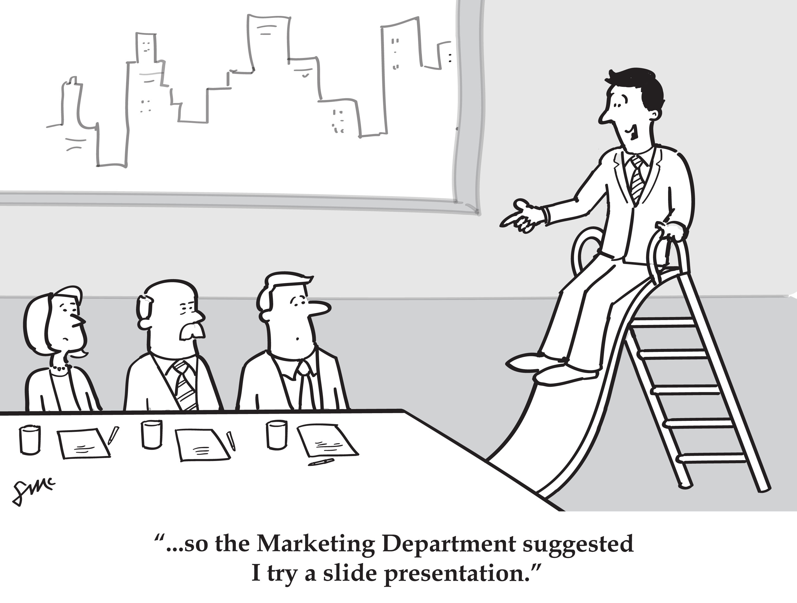

Professor E says:

Everything should be made as simple as possible but no simpler. If you can’t explain it simply, you don’t understand it well enough.

~ Albert Einstein

Learning Activity 1: Notes and
Storyboard
Complete the Learning Activity listed below…

1. Write some notes for a 5-10 minute presentation on your research topic by answering the following questions…

List the Main Topic of your presentation here:

1. Who is the audience?
What are their backgrounds and how much information do they already know about the topic you are presenting?
2.What does the audience expect to see or hear? What’s in it for the audience and why would they care about the topic of your presentation?

3. What do you want to do? Select all that apply…  - Educate / Inform?  - Inspire?  - Gain Interest?  - Persuade?  - Entertain? | Explain how you might do this with your presentation:
4. What are your top 3 key messages?

5. When and where is your presentation going to be?

6. How will you grab and hold the audience’s attention?
7. How long do you have to present your information? | How will you divide up your time amongst topics? List here:

Part Two: Create a Basic Storyboard

Using a storyboard template and the rules of thumb listed in the Objective One content, hand-draw a simple storyboard that addresses the flow and basic ideas for each slide in your 5-10 minute presentation. If it’s easier, sketch your own storyboard template on blank sheets of paper to create a storyboard.

OBJECTIVE TWO
When you complete this objective you will be able to…
Describe interesting and memorable ways to start a presentation

Learning Material

First Impressions

When doing any type of presentation or speech it is important to have an interesting and engaging start. Within the first 30 to 60 seconds of a presentation the audience will be making judgments about your likeability, credibility and believability so you have a small window of time to grab your audiences attention and then lead into your presentation’s introduction. There are a few different ways to have an interesting start to your presentations that might include:

David decided that for his interesting start he wanted to use a relevant statistic about celiac disease:

“More than 330,000 Canadians are believed to be affected by celiac disease with only approximately 110,000 diagnosed. Access to gluten-free foods prevents families with celiac disease from traveling, dining out, and taking part in social activities thereby decreasing their quality of life while increasing the indirect costs associated with the disease.”~ (Canadian Digestive Health Foundation 2015)

David thought that if he could start with an interesting and relevant fact about how many people actually suffer from celiac disease and how it impacts their quality of life that the audience may have more empathy for how many people the disease actually impacts and how many potential customers in restaurants there are for gluten-free menu options. The statistic gives credibility and importance to his presentation and educates the audience.

1. Begin with an Interesting Start… | Before you give your introduction, provide an “interesting start” to help engage your audience.  - Pose an interesting open ended question  - Tell an inspiring story that involves a personal experience about the topic in your presentation.  - Provide and interesting quote about your topic  - Show an interesting photograph or image related to your topic  - Bring in an interesting artefact or object to show relevant to your topic.  - Provide an interesting and engaging statistic that shows relevance or importance to your topic  - Summarize a short concept or idea from an expert’s opinion or finding from a previous research study  - Share a success story relevant to your topic
2. Introduction | The introduction component of your presentation should:  - Introduce the problem that is being addressed  - Explain the context of your presentation  - Directly state the purpose or main message  - Outline the scope of your presentation (how long and how in-depth is your presentation?)  - Provide a basic summarized outline of the key points  (no more than 3-5 key points)
3. Explain at least 1 good reason why the presentation is relevant to the audience or why the audience should care about your topic… | The introduction should also use at least one of these phrases directed at the audience…  - "So what does this topic mean to you?  - "You may be wondering what this topic has to do with you. Let me tell you …  - "Why should you care about this? Because …  - "The importance of this topic to you is …"  Example: David decided to tell his audience that they should care about gluten-free issues because according to recent statistics.... “Rates of celiac disease have nearly doubled in the last 25 years in western countries.” ~(Canadian Digestive Health Foundation 2015)

Adapted from: The 'Magnificent Seven' - 7 characteristics of a great presentation
http://www.speaklikeapro.co.uk/CAB.htm

Learning Activity 2: Interesting
Start

Complete the Learning Activity listed below…
- Figure out an interesting start to your presentation by choosing from the possible approaches below...

- Write the details here about the option you have selected.
(Please note: If you refer to a statistic you must also cite the source from where it came)

- Answer the following questions for information that should be included in your introduction:

- What is the problem that is being addressed in your presentation?
- What is the context of your presentation – why are you doing it?
- What is the purpose or main message of your presentation?
- What is the scope of your presentation, meaning… how many minutes & how in-depth?
- What are the most important 3 key points of your presentation?

- Choose one of these phrases below that is specifically directed at the audience and answer it in a paragraph or less…

- "So what does this topic mean to you?
- "You may be wondering what the topic of my presentation has to do with you? Let me tell you …
- "Why should you care about this? Because …
- "The importance of this topic to you is …"

OBJECTIVE THREE
When you complete this objective you will be able to…
Outline visual design best practices when creating a presentation

Learning Material

When making a presentation it is commonplace nowadays to make use of visual media. It has been noted how “appropriate and effective visual aids increase the effectiveness of the communication by 40% to 50%” (Leech, 2004). Visual aids can also help make a presentation more effective or concise and can help to cut down on the time it takes to convey the information.

For example it would be easier for David to show this chart as a visual aid rather than trying to explain it verbally:

It is important for the Presenter to beware of stylistic choices that can have a negative impact on how the information is perceived. A poor color choice of background or brightly garish colored text can be off putting to viewers. Slides that are overloaded with content, be it visual or textual, can also detract from the content or key message being presented. It is also important to consider making sure that the size of the font can easily read by the audience on the particular device that you are presenting on. Will it be projected or viewed right on your laptop? Make sure to test it out using the same delivery format that you will use during your presentation.

It should be noted that although there is a preference to using presentation software such as PowerPoint, there are other non-electronic visual presentation methods that can be just as effective. These include distributing copies of the presentation to the audience, this is a good back up if you experience technical difficulties at the time of the presentation, the use of whiteboards or chalkboards, flip chards and/ or posters. Other considerations may include videos that can be used to showcase actions that cannot best be explained by text alone. Videos are also very effective at providing personal commentaries or expert interviews within your presentation if time allows.

When designing your Presentation make sure that:
- The text and background colors need enough contrast to be legible.

Example: Dark text on a light background versus light colored text on a dark background.

- Bad color choices can be distracting from content
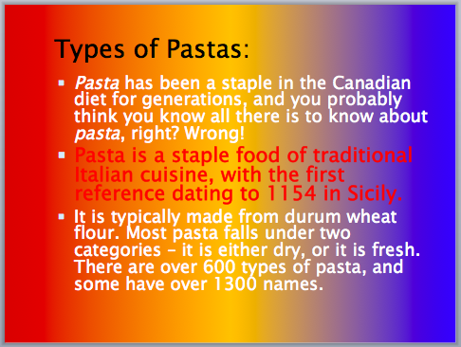

- Too Much Information (TMI) on one slide is a bad thing. Who can read all this? List no more than 1 key concept per slide with a maximum of 3 bullet points. Keep slides simple, clean, clutter-free and to the point. Do not overload slides with images, graphics and text.

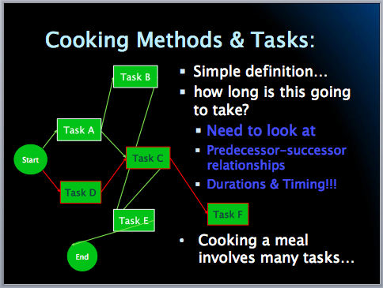

Learning Activity 3: Create
a PowerPoint Presentation
Please Note:
1 key concept per slide with no more than 3 bullet points!

Complete the Learning Activity listed below…

1. Create a Simple PowerPoint

Use information from your notes and answers in Learning Activities 1 & 2 to complete this learning activity. Create a PowerPoint presentation that can be delivered to an audience in 5 minutes.

Please note: You can either use PowerPoint or if you don’t have access to PowerPoint, storyboard what your 5-minute presentation will be. Make sure to include notes on what you will “show” versus what you will “say”.

Your presentation must be divided into 3 sections:
Introduction / Opening (beginning): Identify with a strong memorable start, including the purpose of your presentation, explain why your topic is important for the audience to learn, list the top 3-5 key messages.

Main Content (middle): Describe the details for each of the 3-5 key messages in more detail and provide supporting evidence.

Conclusion (end): summarize the key points or messages and conclude with a closing point or closing argument.

OBJECTIVE FOUR
When you complete this objective you will be able to…
Outline important non-verbal elements to be aware of during face-to-face communications with others.

Learning Material

Just as mentioned in the last objective that when making a presentation it is commonplace nowadays to make use of visual media, but another important part of communication is body language or non-verbal communication.

Humans communicate with each other using language, signage, pictures and written words, but another big component of communication is the non-verbal aspects such as tone of voice, volume of voice, gestures, posture, and facial expressions when interacting with other people.

Albert Mehrabian (born in Iran in 1939) is a well-known psychology professor at UCLA the United States who focused his career on recognizing the importance of verbal and non-verbal messages that people project during a communication. He conducted a study on people in a test group who were trying to discuss their feelings or attitudes with another person. Mehrabian identifies three elements that are important to any face to face communication which include:

Specific Words Used

Tone of Voice

Non-verbal Behavior
(such as facial expression or posture)

According to Mehrabian’s research he suggests that words account for only 7% of what we actually communicate to another person and that tone of voice accounts for 38% of what is communicated, and the type of body language used accounts for a whopping 55% of what is communicated to the receiver. This is referred to as the Mehrabian 7-38-55 Communication Model.

Figure 1: The Mehrabian 7-38-55 Communication Model
Within his research he discovered that in order for a communication to be effective all 3 of these elements had to “compliment” each other or relay the same type of message. For example if someone was using words explaining that they were happy, but the tone of voice and facial expression seemed like a person was sad, that people will be likely to believe the body language over what is being said. Although this model is just a generalization within the specific context of Mehrabain’s research, it points out that tone of voice and body language are major factors in what you are communicating to others around you.

So during a presentation it is important to:

Be aware of the specific words that you are using. Talking too much or too little can impact the message that you are sending out. Think carefully about what the key messages are and be aware of information overload or providing too much information that may distract from the key messages.

Understand that the tone of your voice matters. If you talk too softly you may come across as unconfident or unsure of what you are saying, if you talk too loudly you may be perceived as aggressive or overbearing.

Realize that non-verbal behaviors such as eye contact, facial expressions, hand gestures or posture can support or contradict what we are trying to communicate. Remember that fidgeting or crossed arms can be distracting and project negative impressions. The words, tone and body language used in conjunction together have to compliment each other for our communications to be perceived as positive and effective.

Learning Activity 4:
Ten-Minute Body
Language Exercise

Complete the Learning Activity listed below…

Locate a friend, classmate or colleague that has 10-15 minutes. Ask them to play a quick game of reading body language with you.

- Work together on creating a list of all the ways that a person can non-verbally communicate during a conversation or presentation. Divide the list up into two columns “Positive Non-Verbal Communications” and “Negative Non-Verbal Communications”. Spend no more than 2-3 minutes on this step.

- Once you have your list of positive and negative non-verbal communications – for each item note what the non-verbal communication might convey to others. (Example: Fidgeting might convey nervousness when speaking or disinterest when listening)

- You and your partner will need to take a turn talking for 2-3 minutes each answering the following questions:

- My name is….
- I am ____ years old
- I was born in the city of ________.
- Three interesting facts about me are…

When answering the above questions try to make sure that each speaker practices the list of positive non-verbal communications outlined on your list and avoid the negative non-verbal communications. The listener will keep track and note which non-verbal skills were utilized and which ones weren’t.

Unit 4: Building Vocabulary
Directions:
- Read the list of the terms below
- Use either Google, or an online dictionary, to define each word.
- On a piece of paper, write down the meaning of the word in English
- If English is NOT your first language translate it into your native language using an online translator tool such as https://www.babelfish.com/
- Do this for each word listed below

  - Verbal
  - Non-verbal
  - Visual
  - Complimentary
  - Fidgeting
  - Body Language
  - Tone of Voice
  - Audience
  - Eye Contact
  - Posture
  - Visual Aide
  - Impression
  - Overloaded
  - Impression
  - Auditory
  - Authentic
  - Distraction
  - Engage
  - Statistic
  - Persuade

References
- http://www.garrreynolds.com/preso-tips/prepare/
- http://www.skillsyouneed.com/present/organise-material.html
- http://mi.eng.cam.ac.uk/~cipolla/archive/Presentations/MakingPresentations.pdf
- http://www.quickanddirtytips.com/business-career/public-speaking/how-to-time-a-presentation?page=all
- http://info.genardmethod.com/blog/bid/142073/Grab-Your-Audience-12-Foolproof-Ways-to-Open-a-Speech
- http://www.speaklikeapro.co.uk/CAB.htm
- Van Vliet, V. (2012). Communication Model by Albert Mehrabian. Retrieved [December 09, 2015) from ToolsHero: http://www.toolshero.com/communication-management/communication-model-mehrabian/

Open Educational Resource | TOWES – The Test of Workplace Essential Skills is Canada’s premier literacy and essential skills assessment. Over 120,000 people have used TOWES on their pathways to success in education, employment and life.  