TOWES – Test of Workplace Essential Skills


Unit 1: The SMART Goal

Workbook
Goal Planning Essentials

TOWES Goal Planning Essentials
Care has been taken to obtain copyright permission to reproduce this material. Any information that will enable Bow Valley College to obtain copyright clearance for any material not acknowledged would gladly be received by:
Bow Valley College
345 6th Avenue SE
Calgary AB T2G 4V1
Attn: Copyright Office
email: copyright@bowvalleycollege.ca
© 2015 Bow Valley College

This work is licensed under a Creative Commons Attribution-ShareAlike 4.0 International License.

These resources may be reprinted without additional copyright permission. Full attribution to Bow Valley College must be given. Permission to reproduce for commercial purposes must be obtained in writing from Bow Valley College.


This project/resource was funded through the Alberta Open Educational Resource (ABOER) Initiative, which is made possible through an investment from the Alberta government.

How to use this eWorkbook:

This workbook is meant to guide learners in a step by step method to attaining the stated learning outcome listed on the first page. Print this workbook out and write notes in the margins. Fill in the learning activities using a pencil to allow for mistakes and brainstorming during your learning process.

You may choose to complete this workbook on your own, but it may be helpful to locate a mentor or trusted friend or advisor to give you feedback on your completed learning activities.

Make sure to explain or summarize the main concept of the unit and the purpose of each learning activity to your mentor before you ask for feedback. The purpose of this collaboration is NOT for your mentor to tell you that something is right or wrong, but rather just to give you some constructive and objective feedback that may allow you to look at things in a new way or from a different perspective. Chances are that if you can clearly explain the concepts of the unit and your mentor understands what you have completed in your learning activities - you are on the right track.

Essentially, you have the final say on how you complete your learning activities, and how you use the templates provided in this course, but generally a good rule of thumb is that two heads are always better than one! If you are having difficulties working on your own, ask someone for help or feedback.

 | Step 1: Read the entire workbook.
 | Step 2: Complete the learning activities.
 | Step 3: Ask for feedback on learning activities from a mentor or trusted advisor.
 | Step 4: Use the templates for school, home, or work situations.

 | The Story:  Michael’s SMART Goal

Welcome to Unit 1 of the Goal Planning Essentials Learning Series. Meet Michael. This is his story about SMART goals and how using the SMART goal approach helped Michael work towards his dreams. Of course all dreams big and small involve a few steps along the way. Goals don’t always have to be lofty and grandiose to count. Breaking down your goals into manageable chunks can help you to take baby steps towards the things you want and need to do.

Michael grew up in India and moved to Canada when he was 19 years old and has lived in Calgary for 8 years now. He currently attends Bow Valley College in the evenings taking a writing course to improve upon his English grammar and writing skills as he really enjoys writing short stories and poems in his spare time.

In order to make a living, Michael runs a small home based cleaning business. He knows he needs to increase revenue in order for his business to survive. He wants to obtain more clients and eventually plans to expand his business to include cleaning offices in the downtown area rather than just cleaning homes for people.

In the writing course that Michael is taking they are learning about using clear and concise language. The teacher has instructed the class on how to write SMART goals. In this unit you will see how Michael uses the SMART goals approach to help clarify and pinpoint his thinking (and writing).

Unit 1: The SMART Goal
Q: Why is it important for me to learn this material?
It is important to understand how to write effective and realistic goals in order to reach them. Goal setting can impact all aspects of your personal life, your school experiences and for any job or work place setting.

Q: How long will it take me to complete this workbook?
It should take learners about 1 to 1.5 hours to complete this unit.

Learning Outcome
When you complete this unit you will be able to...
Create skill based and measureable SMART Goals

Learning Objectives
Unit 1 focuses on the following Objectives:
- Characterize the features of a well-written ‘goal’ using the ‘SMART Goals’ criteria.
- Describe the 3 basic components of a SMART Goal.
- Describe the process used for writing a SMART Goal.

Learning Activities
Please complete the following learning activities:
- Learning Activity 1: Matching Game - Words to Definitions
- Learning Activity 2: What is wrong with this SMART Goal?
- Learning Activity 3: Write your own SMART Goals


OBJECTIVE 1
When you complete this objective you will be able to…
Characterize the features of a well-written goal using the ‘SMART Goals’ criteria.

Learning Material

Q: What is a Goal?

A ‘goal’ is a short statement that communicates very specific knowledge, attitudes, behaviors, or skills that work towards a desired result or end objective that a person wants to achieve. You can write very specific and measurable goals using the SMART Goals criteria, which looks like this:

S | Specific:  The goal focuses on one individual task, project, or behavior that focuses on a single end result.
M | Measureable:  The goal should be observable and measureable with details that can be counted or seen.
A | Attainable:  The goal should be realistic and achievable; it also must be within a person’s available resources, workload, timeframe, and abilities.
R | Relevant:  The goal should be related and meaningful to a person’s situation, context, circumstance, or reality.
T | Time bound:  The goal should have a clearly defined time-frame, deadline or specific dates assigned.

 | Professor E says… Keep in mind that it is impossible to determine whether a person has met a goal if it cannot be measured. Unrealistic goals can be de-motivating, so set your goals high but not so high that you cannot reach them. Goals should be relevant to the person’s real life whether its work, home or school related. Ensuring that goals are time sensitive will help to keep goals on track and will help to keep the goal objectives within a reasonable scope or scale.

When thinking about the goals that you want to achieve it is useful to think in terms of verbs. Remember that verbs are “action words”.

The definition of a verb is a word that is used to describe an action, state, or occurrence, and forming the main predicate of a sentence. Using verbs can help us think specifically about the individual actions that we want to achieve with our goals. Look at the verb chart below to get started in thinking about the specific action you want to achieve.

Try to state your SMART goal with one ‘action’ word (or verb) per goal. Avoid using a verb that has a vague meaning such as “understand” or “know”. The more ‘specific’ an objective is - the greater the ‘measurability’.

Here are a few examples of possible verbs to use in order to get started in thinking about your SMART goals. What do you want to achieve?
- Show  - Develop  - Design  - Write  - Illustrate  - Apply  - Create  - Define  - Coordinate  - Build | - Identify  - Calculate  - Improve  - Increase  - Use  - Complete  - Analyze  - Negotiate  - Produce  - Discuss | - Teach  - Explain  - Achieve  - Align  - Replace  - Change  - Adjust  - Refine  - Solve  - Learn

Learning Activity 1: Matching Game
Complete the Learning Activity listed below…
Without looking at the previous pages, match the terms below with the correct definitions by drawing a line connecting the word to the proper definition.

Terms: | Definition:
- Specific  - Measureable  - Attainable  - Relevant  - Time Bound | - The goal should be related and meaningful to a person’s situation, context, circumstance, or reality.  - The goal focuses on one individual task, project, or behavior that focuses on a single end result.  - The goal should have a clearly defined time-frame, deadline or specific dates assigned.  - The goal should be observable with details that can be counted or seen.  - The goal should be realistic and achievable; it also must be within a person’s available resources, workload, timeframe, and abilities.

Please Note: Check your answers using the ‘Answer Key’ located at the end of the workbook

OBJECTIVE 2
When you complete this objective you will be able to…
Describe the 3 basic components of a SMART Goal

Learning Material

Typically well-written goals should include these three basic components:

- Performance: explain what actions or behaviors a person should be able to do (or produce) upon completion of the goal focusing on one verb per goal.

- Conditions: describe any important conditions are under which the performance is to occur (may include any limitations, constraints, boundaries or tools used).

- Criteria: state levels of acceptable performance such as a how well or “to what degree of ability” someone would have to perform the action or achievement

Knowing the basic components of an effective goal helps to form your goal so that it can be more specific, measurable, attainable, relevant and time-bound.

Let’s take a look at a few examples of goals that include a Performance, Condition, and Criteria, then check to see how SMART they are… These are some examples of Michael’s goals. Note the feedback that Professor E gives to each of the examples and how Michael chose to refine each goal.

Sample Goal #1:
“Increase earnings with my home based business this year”

- Performance: Increase Earnings
- Conditions: with my home based business
- Criteria: this year

Professor E’s Feedback: This is a good first draft of a goal, but we can build upon it and improve it by being more specific and measurable. The ‘criteria’ of the goal is a bit weak, as it does not indicate any measures of quality or success. The author needs to detail ‘how’ the increase will occur, quantify the increase and set a deadline that can specifically be measured. Notice how the goal was refined to make it more specific, measurable, and time bound?

Michael’s Revised SMART Goal #1: “Increase earnings with my home cleaning business by 30% this year by obtaining 2 regular on-going residential clients per month and giving each customer a high level of customer service with no cancellations. ”

Sample Goal #2:
“Gain more customers for my neighbourhood cleaning business by the end of the month.”

- Performance: Gain more customers
- Conditions: for my neighborhood cleaning business
- Criteria: by the end of the month

Professor E’s Feedback: This is a worthy goal, however, it might be helpful to include more specific details and conditions to help measure the progress in meeting the goal?
Michael’s Revised SMART Goal #2: “Gain at least 2 regular weekly clients for my cleaning business by the end of the month by placing an ad in the local neighborhood newsletter, classifieds or by using social media”.

Sample Goal #3:
“Write a fiction novel about my childhood growing up in India and then moving to North America and complete writing the book with no spelling errors and within a 5-year time frame.”
- Performance: Write a Fiction Novel
- Conditions: about childhood
- Criteria: no spelling errors and within a 5 year time frame

Professor E’s Feedback: This sounds like a very interesting book and a worthy personal goal. However, if you have your own small business that you are trying to expand, most of your time right now is spent working or trying to obtain new clients. So realistically this goal may not be relevant to your current mission of trying to obtain commercial clients. It may be better to put this one on hold for a while until you get your business going? So by using the SMART criteria, ask yourself if the goal is relevant and achievable to what you have going on in your life right now? Is it realistic to your current responsibilities and workload?

Michael’s Revised SMART Goal #3: “Create a marketing plan for my new business to attract 2 new residential clients per month and 1 commercial client per month over the next year” Once I get my new cleaning business up and running smoothly, I can start writing my personal novel in my spare time.

Professor E says… Notice how each goal starts with a Verb or Action word? Start out by writing a basic goal statement that describes what you want to do, then try to refine it by sharpening various components of the statement.

Learning Activity 2: Sharpen
the SMART goal…
Complete the Learning Activity listed below…
Using the checklist below, can you improve upon or sharpen the various personal, work, home, and school related goals below so that they become SMART goals?

- Clean out the hallway closet and organize all the towels, face clothes and bedding neatly and grouped into similar item types and colors

- Complete my final paper for my political science class

- Write a simple marketing plan for my traveling spa business

- Outline strategies on how to save an extra $1500 a year

- Create a healthy eating and exercise plan

Checklist:

 | Does the goal start with an action word / verb?
 | Does the goal have a clearly stated Performance, Condition and Criteria?
 | Is the goal Specific? Measureable? Achievable? Realistic? And Time-bound?

*Answer Key at back of the workbook: Try them on your own first!

OBJECTIVE THREE
When you complete this objective you will be able to…
Describe the process used for writing a SMART Goal.

Learning Material

This is the general process for writing a good SMART Goal:

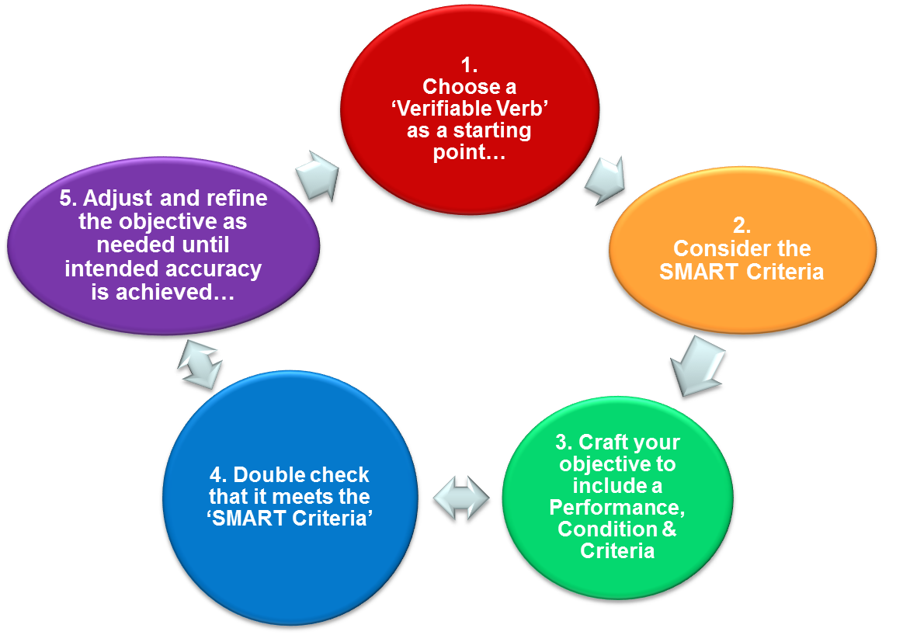

- Choose a verb that best describes the action around your goal…
- Show  - Develop  - Design  - Write  - Illustrate  - Apply  - Create  - Define  - Coordinate  - Build | - Identify  - Calculate  - Improve  - Increase  - Use  - Complete  - Analyze  - Negotiate  - Produce  - Discuss | - Teach  - Explain  - Achieve  - Align  - Replace  - Change  - Adjust  - Refine  - Solve  - Learn

Professor E says… Remember that the verb should be “verifiable” meaning that it is something you can actually demonstrate, see, or measure.

Example: The word “understand” is not considered a verifiable verb because it is not something that you could easily see and it cannot be directly demonstrated.

- Consider the SMART Criteria:

When thinking about your goal, make sure to consider these questions:

S | Specific: Does the goal focus on one individual task, project, context or behavior that focuses on a single end result?
M | Measurable: Is the goal observable and measureable with details that can be counted or seen?
A | Attainable: Is the goal realistic and achievable; is it within a person’s available resources, workload, timeframe, and abilities?
R | Relevant: Is the goal related and meaningful to a person’s situation, context, circumstance, or reality?
T | Time bound: Does the goal have a clearly defined time frame, deadline or specific dates assigned to it?

- Write or craft your goal’s objective to include a Performance, Condition and Criteria.

Can you answer “Yes” to the following?

- Performance: Does your goal explain what actions or behaviors a person should be able to do (or produce) upon completion of the goal focusing on one verb per goal?

- Conditions: Does your goal describe any important conditions are under which the performance is to occur (which may include any limitations, constraints, boundaries or tools used)?

- Criteria: Does your goal state levels of acceptable performance such as a how well or “to what degree of ability” someone would have to perform the action or achievement to be successful?

- Once you have written the first draft of your goal… Double check that your goal is SMART…

Can you answer “Yes” to these questions below when evaluating your goal?

S | Specific: Does the goal focus on one individual task, project, context or behavior that focuses on a single end result?
M | Measurable: Is the goal observable and measureable with details that can be counted or seen?
A | Attainable: Is the goal realistic and achievable; is it within a person’s available resources, workload, timeframe, and abilities?
R | Relevant: Is the goal related and meaningful to a person’s situation, context, circumstance, or reality?
T | Time bound: Does the goal have a clearly defined time frame, deadline or specific dates assigned to it?

- Adjust and refine your goal as needed until you have created a SMART goal that you are happy with.

Learning Activity 3: Write your
own SMART Goals

Please Note:
Keep in mind this activity can be quite challenging – good SMART goals can take anywhere from 10 to 30 minutes each to write!
Complete the Learning Activity listed below…

Part 1: Create SMART Goals

In the box below, write down a list of your goals for
work, home, school or your personal life. Write at least 3 to 4 goals. Once you have them written down check that your goals fit the SMART goals process and framework listed on the previous pages in the workbook.

- Choose a Verb
- Consider Performance, Condition, Criteria
- Is it S.M.A.R.T?

Part 2: Create an Action Plan

For each goal that you have written, write out the steps that you think you would need to take in order to reach the specific SMART goal.

Goal: | Steps:
Ask your mentor for feedback on this activity once you are done!

Unit 1: Building Vocabulary | 
Directions:
- Read the list of the 27 terms below
- Use either Google, or an online dictionary, to define each word.
- On a piece of paper, write down the meaning of the word in English
- If English is NOT your first language translate it into your native language using an online translator tool such as https://www.babelfish.com/
- Do this for each word listed below

  - Characterize
  - Objective
  - Criteria
  - Specific
  - Measurable
  - Attainable
  - Relevant
  - Time-bound
  - Demotivating
  - Scope
  - Scale
  - Vague
  - Measurability
  - Circumstance
  - Observable
  - Quantify
  - Detail
  - Specify
  - Mission
  - Implemented
  - Process
  - Limitations
  - Constraints
  - Boundaries
  - Evaluating
  - Framework
  - Frivolous

 Learning Activity 1 Answers:

Without looking at the previous pages, match the terms below with the correct definitions by drawing a line connecting the word to the proper definition.

Terms: | Definition:
- Specific (2)  - Measureable (4)  - Attainable (5)  - Relevant (1)  - Time Bound (3) | - The goal should be related and meaningful to a person’s situation, context, circumstance, or reality.  - The goal focuses on one individual task, project, or behavior that focuses on a single end result.  - The goal should have a clearly defined time-frame, deadline or specific dates assigned.  - The goal should be observable with details that can be counted or seen.  - The goal should be realistic and achievable; it also must be within a person’s available resources, workload, timeframe, and abilities.

Learning Activity 2 Answers:

Using the checklist below, can you improve upon or sharpen the various personal, work, home, and school related goals below so that they become SMART goals?

- Clean out the hallway closet and organize all the towels, face clothes and bedding neatly and grouped into similar item types and colors

Feedback: Think about adding a time frame to the statement to include the T for time-bound. When should this task be completed by?

Example: Clean out the hallway closet and organize all the towels, face clothes and bedding neatly and grouped into similar item types and colors by Wednesday evening of next week.

- Complete my final paper for my political science class

Feedback: Perhaps consider the Performance, Conditions and Criteria in this statement. What factors about the quality or detail included in the final paper? Will the essay be written in a special format, or have a certain number of words? Are you aiming for a specific grade or mark indicating the quality level? Include details that reflect what quality you are aiming for and elements of time commitments or deadlines.

Example: Complete my final paper for my political science class by spending 2-3 hours per evening for one week prior to the due date and aiming for a minimum 85% grade.

- Write a simple marketing plan for my traveling spa business

Feedback: What do you hope that the marketing plan would accomplish? What do you hope to do with the marketing plan?

Example: Write a simple marketing plan for my traveling spa business to present to the bank in order to qualify for a loan and purchase a proper vehicle and portable spa supplies to grow the business by 50% over the next year.

- Outline strategies on how to save an extra $1500 a year

Feedback: What kind of strategies and in what context is this smart goal? Is this for home or business? It needs to be specific, measurable, attainable, realistic, and time bound… so make sure each element is there.

Example: Outline 10 personal money saving strategies and cost saving activities that I can easily implement on a daily basis to save $1500 extra in one year for my personal finances.

- Create a healthy eating and exercise plan

Feedback: Create the healthy eating plan for whom? What will the healthy eating plan involve and what is the purpose of it? Is there a time frame or time element involved?

Example: Create a healthy eating plan that includes all meals, recipes and shopping lists for an entire month of eating and will include all major food groups with no processed foods or refined sugars in the meals.

Learning Activity 3 Answers:

This learning activity is subjective and contextual to the information or example that the student provides –there is no answer key. Just make sure that the checklists and process was followed. You should be able to answer yes to all of the following if your goal is SMART.

Can you answer “Yes” to the following?

S | Specific: Does the goal focus on one individual task, project, context or behavior that focuses on a single end result?
M | Measurable: Is the goal observable and measureable with details that can be counted or seen?
A | Attainable: Is the goal realistic and achievable; is it within a person’s available resources, workload, timeframe, and abilities?
R | Relevant: Is the goal related and meaningful to a person’s situation, context, circumstance, or reality?
T | Time bound: Does the goal have a clearly defined time frame, deadline or specific dates assigned to it?

Can you answer “Yes” to the following?

- Performance: Does your goal explain what actions or behaviors a person should be able to do (or produce) upon completion of the goal focusing on one verb per goal?

- Conditions: Does your goal describe any important conditions are under which the performance is to occur (which may include any limitations, constraints, boundaries or tools used)?

- Criteria: Does your goal state levels of acceptable performance such as a how well or “to what degree of ability” someone would have to perform the action or achievement to be successful?

References

Mager. Robert F. (1975) Preparing Instructional Objectives, Second Edition. Fearon Publishers Inc. Belmont, California

Mager. Robert F. (1987) Goal Analysis: How to Clarify Your Goals so you can Actually Achieve Them. Fearon Publishers Inc. Belmont, California

Open Educational Resource | TOWES – The Test of Workplace Essential Skills is Canada’s premier literacy and essential skills assessment. Over 120,000 people have used TOWES on their pathways to success in education, employment and life.    

