TOWES – Test of Workplace Essential Skills

Unit 2: Sharpening Goals & Assessing Decisions

Workbook
Goal Planning Essentials

TOWES Goal Planning Essentials
Care has been taken to obtain copyright permission to reproduce this material. Any information that will enable Bow Valley College to obtain copyright clearance for any material not acknowledged would gladly be received by:
Bow Valley College
345 6th Avenue SE
Calgary AB T2G 4V1
Attn: Copyright Office
email: copyright@bowvalleycollege.ca
© 2015 Bow Valley College

This work is licensed under a Creative Commons Attribution-ShareAlike 4.0 International License.

These resources may be reprinted without additional copyright permission. Full attribution to Bow Valley College must be given.


This project/resource was funded by the Alberta Open Educational Resource (ABOER) Initiative, which is made possible through an investment from the Alberta government.

How to use this eWorkbook:

This workbook is meant to guide learners in a step by step method to attaining the stated learning outcome listed on the first page. Print this workbook out and write notes in the margins. Fill in the learning activities using a pencil to allow for mistakes and brainstorming during your learning process.

You may choose to complete this workbook on your own, but it may be helpful to locate a mentor or trusted friend or advisor to give you feedback on your completed learning activities.

Make sure to explain or summarize the main concept of the unit and the purpose of each learning activity to your mentor before you ask for feedback. The purpose of this collaboration is NOT for your mentor to tell you that something is right or wrong, but rather just to give you some constructive and objective feedback that may allow you to look at things in a new way or from a different perspective. Chances are that if you can clearly explain the concepts of the unit and your mentor understands what you have completed in your learning activities - you are on the right track.

Essentially, you have the final say on how you complete your learning activities, and how you use the templates provided in this course, but generally a good rule of thumb is that two heads are always better than one! If you are having difficulties working on your own, ask someone for help or feedback.

 | Step 1: Read the entire workbook.
 | Step 2: Complete the learning activities.
 | Step 3: Ask for feedback on learning activities from a mentor or trusted advisor.
 | Step 4: Use the templates for school, home, or work situations.

 | The Story:  Lisa’s Big Decisions

Welcome to Unit 2 of the Goal Planning Essentials Learning Series. Meet Lisa. This is her story about how sometimes we need a little help in trying to assess our goals and decisions.

Lisa is a hard working young woman who likes to work with people and has a special gift caring for children and the elderly. Kids have always been drawn to Lisa and she worked for a years as a baby sitter and nanny over the summer holidays while she attended school. She is currently enrolled in a Nursing program and has yet to graduate. Lisa is at the stage in her life where she is making some big decisions about her education, work situation and living arrangements. She has always been close with her Dad and decided to go to him for some advice and support.

Lisa’s Father Frank works as a Business Analyst for a large company and is often required to brainstorm, and problem solve on a daily basis. He told Lisa about some simple tools that he uses when he is having difficulty trying assess his options, prioritize goals and make decisions. “When I have a problem that I need to solve, I need to sit down and think of all the possible solutions that might work before choosing a direction, I call this brainstorming” said Lisa’s Dad.

Frank went on to explain, “I like to get a piece of paper out and draw a little graphic that looks like this…”

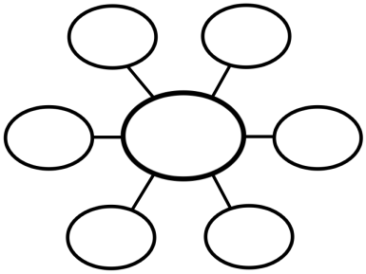

Lisa’s Dad then outlined how he writes down the problem in the middle circle and then on each little arm writes in a possible solution that might work. He referred to it as a “Graphic Organizer” to help organize his thoughts and give a visual mind map to what he is thinking. He also explained how a person could use this same idea for virtually any problem or idea that needs careful examination. Frank pointed out that once he has a clearer direction, he then conducts a:

- SWOT analysis,
- PMI analysis or
- Options analysis.

Note: each of these tools will be explained further in this unit of learning.

“Let’s look up the word ‘risk’ in the dictionary honey,” suggested Frank. He promptly pulled the dictionary off the shelf beside him. He opened it up to the word ‘risk’ and read the following:

Risk: A probability or threat of damage, injury, liability, loss, or any other negative occurrence that is caused by external or internal weakness or threat, that may be avoided by careful planning, awareness and action.

“All these analysis tools are meant to help you consider the levels of risk and what types of risk factors may impact the decisions we make.” Frank explained. From this knowledge we have more information or awareness to sharpen, change, adapt or re-think our decisions.

In this unit you will see examples of how Lisa used some of these analysis tools to help guide and organize her thinking so she could assess her options and make the best decisions for herself. Lisa was surprised at how knowledgeable her Dad was about problem solving and was excited to try out some of these concepts to help her to organize, prioritize and sharpen her goals and decisions.

“Thanks Dad!” exclaimed Lisa. She was glad she asked for his guidance and support.

Unit 2: Sharpening Goals & Assessing Decisions
Q: Why is it important for me to sharpen my goals?
Analyzing goals or decisions can help us to gain awareness for strengths, and shed light on weaknesses. That way we can make sure that our goals and decisions are clearly defined and sharp. Having this insight can also help us to address threats, risks, or issues that may influence how we make future decisions.
Q: How long will it take me to complete this workbook?
It should take learners about 1.5 to 2 hours to complete this unit.

Learning Outcome
When you complete this unit you will be able to...
Apply various analysis tools to help strengthen and sharpen SMART Goals by looking at advantages, disadvantages, threats, external and internal factors that may impact our ability to reach our goals.

Learning Objectives
Unit 2 focuses on the following Objectives:
- Explain the purpose and function of a SWOT Analysis and how to conduct the analysis on a SMART Goal.
- Explain the purpose and function of a PMI Analysis and how to conduct one on a decision related to a SMART goal.
- Explain how an Options Analysis works and how it can help a person to consider long-term or short-term impacts related to a SMART goal.

Learning Activities
Please complete the following learning activities:
- Learning Activity 1: Conduct a SWOT Analysis
- Learning Activity 2: Conduct a PMI Analysis
- Learning Activity 3: Conduct an Options Analysis


OBJECTIVE 1
When you complete this objective you will be able to…
Explain the purpose and function of a SWOT Analysis and how to conduct the analysis on a SMART Goal.

Learning Material

Q: What is a SWOT Analysis?

A ‘SWOT’ analysis was originally developed to help businesses assess themselves and how they stack up against their competitors. However, as Lisa’s Dad pointed out in the case study at the start of this unit, it can also be used for home, school, workplace or personal situations as well. A SWOT analysis can help you to personally evaluate your own personal Strengths, Weaknesses, Opportunities or Threats within a situation, project or goal.

Ask yourself the following questions:

S | Strengths:  What characteristics, talents or abilities do I have that make me stand out from others and will help me to achieve my SMART goal(s)?  Example: Any type of technical skills or people skills related to the goal
W | Weaknesses:  What weaknesses do I have that I can improve upon to increase my chances of success? What areas of personal growth could I focus on to become more skilled?  Example: A weakness might include public speaking, reading skills, or other areas of personal improvement…
O | Opportunities:  What types of opportunities exist that can help me to eliminate or address my weaknesses or threats in a positive way?  Example: If one of my weaknesses is public speaking, it can be seen as an opportunity to take a Public Speaking Class or seminar.
T | Threats:  What types of threats or risks exist that may interfere with my SMART goal?  Example: a threat may be anything that may be seen as a possible risk that can stop your goal from happening.

Let’s take a look at Lisa’s example of a SMART goal and how she conducted a SWOT analysis on it…

Lisa’s SWOT Analysis Template
State SMART Goal or situation that you are assessing here:
Obtain a higher paying job in a health care related field within the next year
What characteristics, talents or abilities do I have that make me stand out from others and will help me to achieve my SMART goal(s)? | STRENGTHS:  - Strong technical knowledge with computers  - Personable and friendly, good at putting people at ease.  - Experience working with children | OPPORTUNITIES:  - Finish my nursing program  - Volunteer at a health care related job for one day per week for 6 months | What types of opportunities exist that can help me to eliminate or address my weaknesses or threats in a positive way?
What weaknesses do I have that I can improve upon to increase my chances of success? What areas of personal growth could I focus on to become more skilled? | WEAKNESSES:  - Not done my nursing program yet  - Inexperienced in previous health care related jobs  - Live 40 min out of city limits, so is a long commute to get to downtown where jobs are | THREATS:  - Other graduates in my program have more experience  - Not having enough time to get school work done and work on addressing opportunities  - Feeling frustrated or unmotivated | What types of threats or risks exist that may interfere with my SMART goal? External or internal threats?

After taking a look at the examples in the personal SMART goal SWOT Analysis above you can see how a person can start to form a ‘strategic plan’ that will help enable them to achieve their smart goal.

This simple template really helped Lisa to see all her options and to think about her SMART goal from various perspectives.

From the SWOT analysis we can take some proactive steps that will help to minimize threats and give us an even better chance for success in reaching our own SMART goals. Steps that might be taken in the above example include:

- Completing the nursing program as soon as possible
- Look for potential volunteer opportunities
- Create a weekly time schedule to help manage my time effectively
- Keep a positive attitude by focusing on all my small successes

By taking the time to conduct a SWOT analysis we can start to see or think about steps or activities that we can do to help us work towards reaching our goals. This analysis also helps us to address any negative threats or risks that may interfere with reaching our SMART goals. You may also notice that you might need to adjust your SMART goal slightly if the threats or weaknesses are too great.

Steps to completing a SWOT Analysis:
 | - Identify the SMART goal you are analyzing.  Do one SWOT analysis for each SMART goal.
- List your STRENGTHS.
Focus on internal strengths, or things you do very well as it relates to the SMART goal you are analyzing.
- Next, list your WEAKNESSES.
These will be internal, and are things that negatively impact your work or ability to reach your goal.

- Brainstorm possible OPPORTUNITIES.
Note: These are usually external factors as opposed to internal strengths and weaknesses.

- Finally, identify any of your possible THREATS.
Note: These are also usually external factors too but in personal examples internal factors may also be relevant.

- Lastly, list possible actions and prioritize them
(in order of importance or achievability). Ask yourself if you need to fine-tune or adjust your SMART goal to make it more attainable or realistic.

 | Professor E says… Conducting a SWOT analysis gives us a structured way to look at our internal strengths and weaknesses as well as external opportunities and potential threats. A SWOT analysis can help us form a strategic plan to successfully reach a SMART goal or deal with a situation.

Remember; use a Graphic Organizer if you need to brainstorm ideas for individual strengths, weaknesses, opportunities or threats. Put the word “Strength” in the middle circle. Try to think of all the strengths, write each of the strengths that you can think of in the outlying circles. Do this again each time when thinking about: weaknesses, opportunities and threats.

Learning Activity 1: Conduct a
SWOT Analysis
Complete the Learning Activity listed below…
SWOT Analysis Template
State your own personal SMART Goal here:

What characteristics, talents or abilities do I have that make me stand out from others and will help me to achieve my SMART goal(s)? | STRENGTHS: | OPPORTUNITIES: | What types of opportunities exist that can help me to eliminate or address my weaknesses or threats in a positive way?
What weaknesses do I have that I can improve upon to increase my chances of success? What areas of personal growth could I focus on to become more skilled? | WEAKNESSES: | THREATS: | What types of threats or risks exist that may interfere with my SMART goal? External or internal threats?

From looking at your SWOT analysis above list 3-5 proactive steps that can you do that will help to minimize threats and give you an even better chance for success in reaching our own SMART goal…

1.

2.

3.

4.

5.

As a final step, ask yourself: Based on the results of the SWOT analysis, do I need to adjust or tweak my SMART goal slightly to make it more achievable or realistic? If you do decided to fine tune your SMART goal slightly, write the revised goal down here and provide a quick explanation as to why you needed to change it…

Ask your mentor for feedback on this activity once you are done!

OBJECTIVE 2
When you complete this objective you will be able to…
Explain the purpose and function of a PMI Analysis and how to conduct one on a decision related to a SMART goal.

Learning Material

There are various analysis tools that are commonly used to analyze goals or situations from all sides and viewpoints. Another tool similar to the SWOT Analysis is the PLUS MINUS INTERESTING Analysis (PMI). The PMI analysis tool was was developed by Edward DeBono who is one of today’s leading experts on applying critical thinking and thoughtful decision making approaches to educational and work place situations.

The PMI analysis is a good way of weighing the pros, cons and implications of a future decision, idea, subject or topic. PMI is a good technique that can be used to check whether or not the current direction or course of action is worth taking. The purpose of the analysis is to direct your attention to the positive, negative and interesting aspects of a particular idea, subject or decision.

The PMI categories can be described as:

- PLUS: list all of the positive aspects of the idea, subject, topic or the positive results from taking action on decision.

- MINUS: list all the negative aspects or results of the topic, subject or decision.

- INTERESTING: list anything else about the decision, subject or idea that is worth noting but doesn’t fit easily into the other categories. Can be a neutral observation, rather than positive or negative influence.

Let’s look at an example of using a PMI analysis within the context of a specific SMART goal. In the previous objective within this workbook we looked at a SWOT analysis of a SMART goal. In that example we noticed that one of the threats listed required a course of action or decision to:

- “Relocate to a new place to live closer to the downtown core where most of the jobs are”

Next, we will conduct a sample PMI analysis on whether or not it’s worth taking action on ‘Relocating to a new place to live closer to the downtown core’.

To conduct the PMI analyses make a simple chart with the decision listed at the top and one column for each of the Plus, Minus or Interesting categories. Remember that each aspect listed must be directly related to the main topic…

List decision, topic, idea or subject here:

“Should I relocate to a new place to live closer to the downtown core where most of the jobs are?”

Plus (+) | Minus (-) | Interesting (☺)
- Would be easy to look for jobs and attend interviews.  - Employers would see that I live nearby and may see that as a positive attribute to hiring me.  - Once employed I would spend less time travelling to get to work.  - Would give me the option to have 2 part time jobs because of short commute distances.  - Would spend less money on gas.  - Could walk to work so I would get lots of exercise. | - Would be more expensive.  - Would probably be limited selection.  - Would live in a smaller place compared to where I am living now.  - Would be very expensive to park my car if I didn’t have my own parking spot, may have to sell my car. | - Would live close to amenities such as theatres, parks, museums and cool cafes or restaurants.  - Would attend more events such as theatre and live music.  - Would be able to socialize with friends more.

Assigning values is the next step of the PMI analysis process. After you have completed your columns, assign a value to each reason. Use the following rating scale to assign vales to each attribute based on how positive or negative it feels or how important it is to your life. The following SIMPLE rating scale can be used:

+2 Points | +1 Point | -1 Point | -2 Points
Very Favorable… | Somewhat Favorable… | Unfavorable… | Very Unfavorable…

See an example below of how we calculated the values to help give us a recommended positive or negative result.
+2 Points | +1 Point | -1 Point | -2 Points
Very Favorable… | Somewhat Favorable… | Unfavorable… | Very Unfavorable…

List decision, topic, idea or subject here:

“Should I relocate to a new place to live closer to the downtown core where most of the jobs are?”

Plus (+) | Minus (-) | Interesting (☺)
- Would be easy to look for jobs and attend interviews. (+2 points)  - Employers would see that I live nearby and may see that as a positive attribute to hiring me.  (+2 points)  - Once employed I would spend less time travelling to get to work.  (+2 points)  - Would give me the option to have 2 part time jobs because of short commute distances. (+1 point)  - Would spend less money on gas.  (+2 points)  - Could walk to work so I would get lots of exercise.  (+2 points) | - Would be more expensive.  (-2 points)  - Would probably have less selection. (-1 point)  - Would live in a smaller place compared to where I am living now.  (-1 point)  - Would be very expensive to park my car if I didn’t have my own parking spot, may have to sell my car. (-2 points)  - Would miss living in the country  (-2 points) | - Would live close to amenities such as theatres, parks, museums, cafes or restaurants.  (+1 point)  - Would attend more events such as theatre and live music. (+1 point)  - Would be able to socialize with friends more.  (+1 point)
Total = +11 | Total = -8 | Total = +3

The scores are shown as +11 (Plus) – 8 (Minus) + 3 (Interesting) = +6
So in the instance shown above we calculated a “+6” showing that the positive benefits of moving downtown outweigh the negatives of living farther away.

A more complicated decision may require that you use a more complicated rating scale. For the same example the user felt he had a more diverse range of feelings towards the various reasons that he wanted to be considered in the final decision so a more diverse rating scale was used as seen below.

- 5 | - 4 | - 3 | - 2 | -1 | +1 | +2 | +3 | +4 | +5
←Very Unfavorable—Moderately Unfavorable---Somewhat Favorable---Favorable---Very Favorable→

Please note: you can make your rating scale as simple or complex as you feel is necessary for the type of decision you are making. This is just an example!

List decision, topic, idea or subject here:

“Should I relocate to a new place to live closer to the downtown core where most of the jobs are?”
Plus (+) | Minus (-) | Interesting (☺)
- Would be easy to look for jobs and attend interviews. (+4)  - Employers would see that I live nearby and may see that as a positive attribute to hiring me. (+3)  - Once employed I would spend less time travelling to get to work. (+5)  - Would give me the option to have 2 part time jobs because of short commute distances. (+3)  - Would spend less money on gas. (+4)  - Could walk to work so I would get lots of exercise. (+5) | - Would be more expensive. (-5)  - Would probably have less Selection. (-5)  - Would live in a smaller place compared to where I am living now. (-3)  - Would be very expensive to park my car if I didn’t have my own parking spot, may have to sell my car. (-4)  - Would miss living in the country  (-4) | - Would live close to amenities such as theatres, parks, museums, cafes or restaurants. (+3)  - Would attend more events such as theatre and live music. (+3)  - Would be able to socialize with friends more. (+3)
Total = +24 | Total = -21 | Total = +9
The scores are shown as +24 (Plus) – 21(Minus) + 9 (Interesting) = +12

Learning Activity 2: Conduct a
PMI Analysis
Complete the Learning Activity listed below…
List one of the steps related to your SMART goal or one of the decisions that came out of your SWOT analysis and fill in the PMI chart below. Draw your own chart on a piece of paper if you need more room to write…

List decision, step, topic, idea, or subject here:

Plus (+) | Minus (-) | Interesting (☺)
Total = | Total = | Total =

+2 Points | +1 Point | -1 Point | -2 Points
Very Favorable… | Somewhat Favorable… | Unfavorable… | Very Unfavorable…

Calculated total: (_____Plus) (_____ Minus) (______Interesting) = _______
Ask your mentor for feedback on this activity once you are done!

OBJECTIVE THREE
When you complete this objective you will be able to…
Explain how an Options Analysis works and how it can help a person to consider long-term or short-term impacts related to a SMART goal.

Learning Material

There are many option analysis tools out there to help us assess risk, problems or issues in a way that will add structure to our thinking process and the way we look at things. Each analysis tool may not be relevant in every instance and so it is up to you to apply the appropriate analysis tool for the situation, issue, decision or problem that you are dealing with. In this Unit of learning you will get a chance to use a few types of analysis tools. This will give you experience with using a variety of analysis tools to help you clearly understand the issues and make solid decisions that can help you reach your goals.

Professor E says… “If I had an hour to solve a problem I'd spend 55 minutes thinking about the problem and 5 minutes thinking about solutions”
-Albert Einstein

The next analysis tool we will be looking at is called the ‘Options Analysis’. This approach focuses on looking at the long-term and short-term effects as compared to focusing on the pros and cons of an option, as seen previously in the PMI model. Take a look at the following chart:

List decision, step, topic, idea, or subject here:

Long Term Effects |  | Short Term Effects
-  -  -  -  - |  | -  -  -  -  -
Level of Risk: | Certainty of Outcomes: | Bias Free: | Ease to Carry Out:
High  Medium  Low | High  Medium  Low | Yes  No | Easy  Medium  Difficult

Looking back at the case study at the beginning of the unit and how Lisa’s Dad defined what the term risk means:

Risk: A probability or threat of damage, injury, liability, loss, or any other negative occurrence that is caused by external or internal weakness or threat, that may be avoided by careful planning, awareness and action.

Remember that risks range from low to high in probability. Let’s think of a simple example of say crossing the street and the probability of being hit by a car. If we use the cross walk to cross the street, the probability of being hit by a car would be considered pretty low. If we decided NOT to use the cross walk and just cross the street in the middle of the busy road, the probability of that risk may increase to a higher level.

So it is important to consider that all options have certain risks involved. It is important to just think about the potential risks associated with every decision we make in order to fully understand the long-term or short-term effects.

In the following example we will analyze a SMART goal to see if it gives us any insights or clarity on our goal. This type of analysis can also give us clues as to whether or not we need to adjust the scope of our goal or sharpen it a bit.

Options Analysis:
List decision, step, topic, idea, or subject here:

Create a healthy exercise and eating plan with the help of a nutritionist and then follow it strictly for one year.

Long Term Effects: |  | Short Term Effects:
- Better overall health  - Less chance of developing disease  - Age less noticeably  - Better mobility in old age  - Less chance of injury when doing physical activity  - |  | - I will feel better physically  - My appearance will look better and healthier  - I will have more energy  - I will feel better emotionally that I am being proactive about my own health
Level of Risk: | Certainty of Completion: | Bias Free: | Ease to Carry Out:
High  Medium  X Low | High  X Medium  Low | X Yes  No | Easy  X Medium  Difficult

Notice how conducting an Options Analysis can help to put a SMART goal in perspective? We can clearly see the benefits of the goal and get a clearer idea on how difficult it will be to achieve and if there are any risks associated with it.
If the results of the analysis look like the risk is high, the certainty of completion is low, and that it’s going to be difficult to carry out, then that may be an indicator that you need to scale back the scope of your goal.

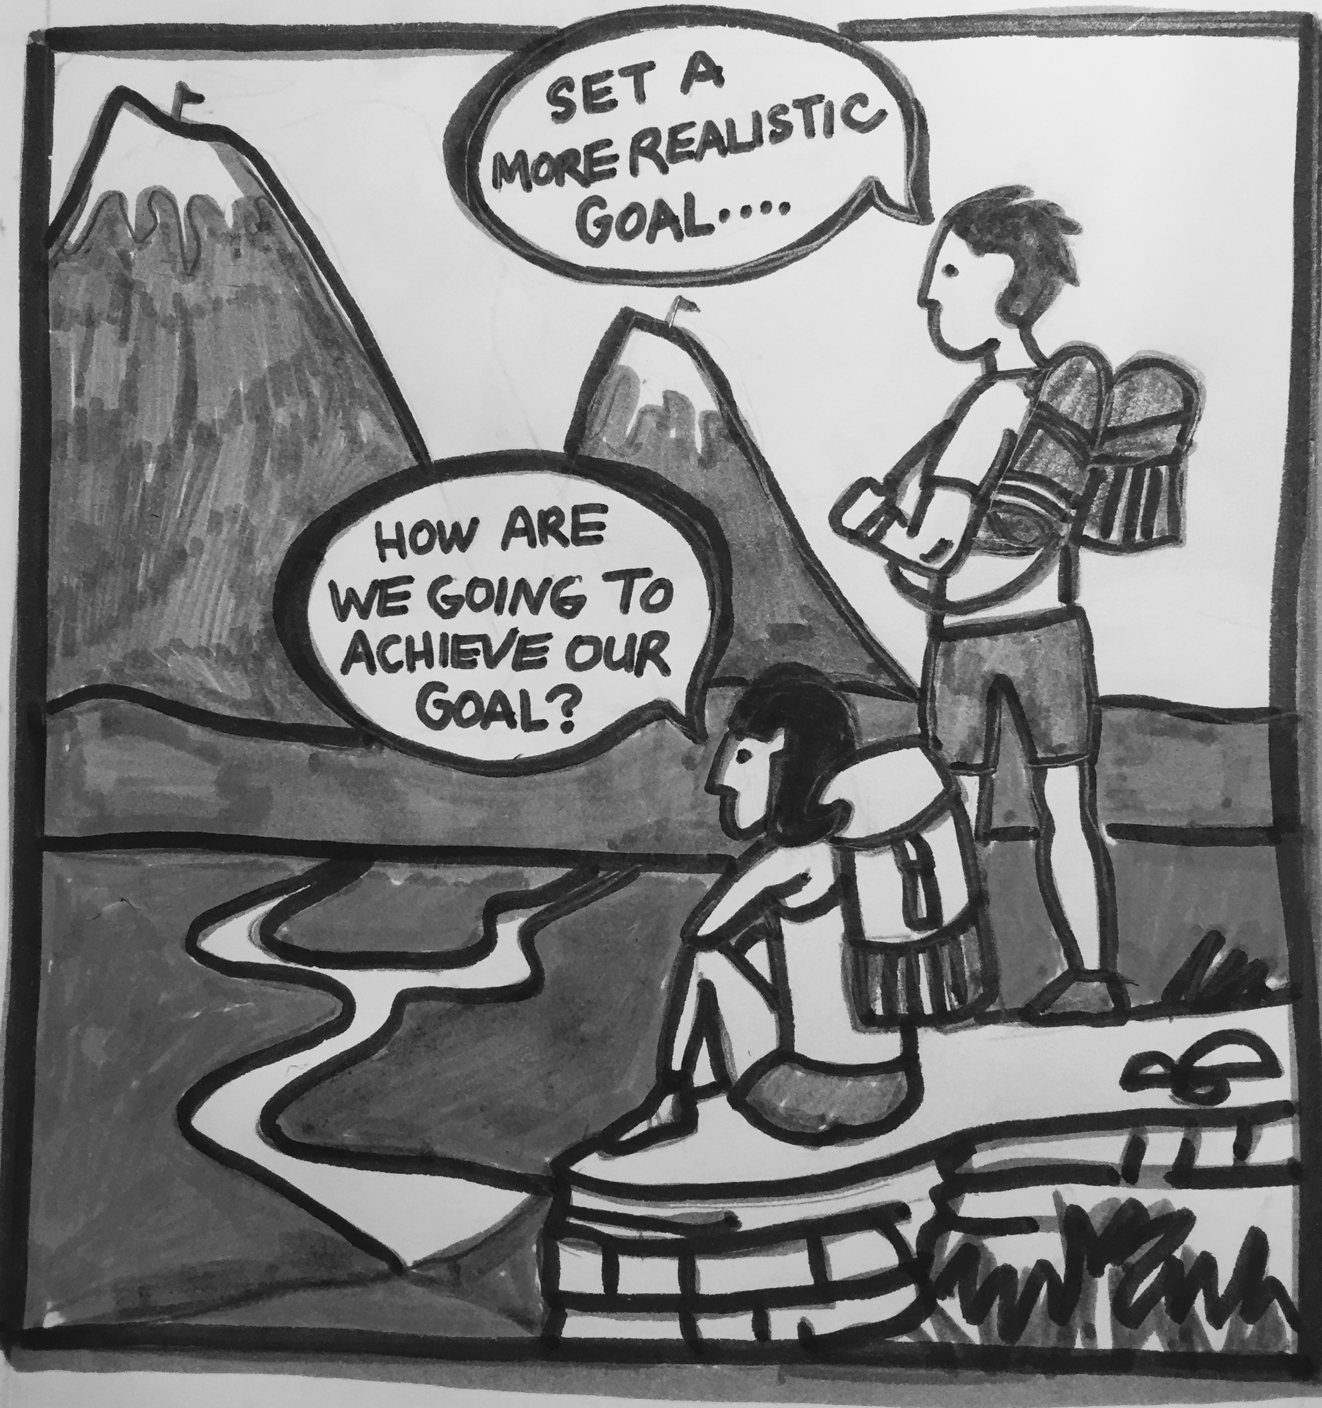

Learning Activity 3: Conduct an
OPTIONS Analysis
Complete the Learning Activity listed below…
List one of the steps related to your SMART goal or one of the decisions that came out of your SWOT analysis and fill in the Options Analysis chart below.

List decision, step, topic, idea, or subject here:

Long Term Effects |  | Short Term Effects
-  -  -  -  -  -  - |  | -  -  -  -  -  -  -
Level of Risk: | Certainty of Outcomes: | Bias Free: | Ease to Carry Out:
High  Medium  Low | High  Medium  Low | Yes  No | Easy  Medium  Difficult

Q: Do you feel after conducting the analysis that you will need to adjust the scope or scale of your goal? Why or why not?

Ask your mentor for feedback on this activity once you are done!

Unit 2: Building Vocabulary | 
Directions:
- Read the list of the 26 terms below
- Use either Google, or an online dictionary, to define each word.
- On a piece of paper, write down the meaning of the word in English
- If English is NOT your first language translate it into your native language using an online translator tool such as https://www.babelfish.com/
- Do this for each word listed below

  - Technical Skill
  - Characteristic
  - Sharpen
  - Strength
  - Weakness
  - Opportunity
  - Threat
  - Strategy
  - Strategic
  - Plan
  - Analysis
  - Prioritize
  - Risk
  - Achievability
  - Fine-tune
  - Talents
  - Internal
  - External
  - Tweak
  - Explanation
  - Critical Thinking
  - Implications
  - Aspects
  - Attribute
  - Rating-Scale
  - Results

References
- Forbes Leadership / How to Conduct a SWOT Analysis: http://onforb.es/11agpRk

- Washington Edu: Weighing the Pros and Cons of a Decision: https://www.washington.edu/research/rapid/resources/toolsTemplates/plus_minus_interesting.pdf

- Risk Definition: http://www.businessdictionary.com/definition/risk.html#ixzz3qxOsm3w6

Open Educational Resource | TOWES – The Test of Workplace Essential Skills is Canada’s premier literacy and essential skills assessment. Over 120,000 people have used TOWES on their pathways to success in education, employment and life.  